Multiplexers

Description –

Several different kinds of multiplexers are contained within the CPU architecture. They provide support for selecting appropriate values from several potential values based on things like instruction operation codes, write back enabled, etc.

A 16-bit 4x1 multiplexer, made from chained 1-bit 4x1 multiplexers, is utilized within the register file to determine register data. Additionally, a 16-bit 2x1 multiplexer is used for data in the WB phase of the CPU.

Diagram –

16 bit 4x1 Mux (Register File)

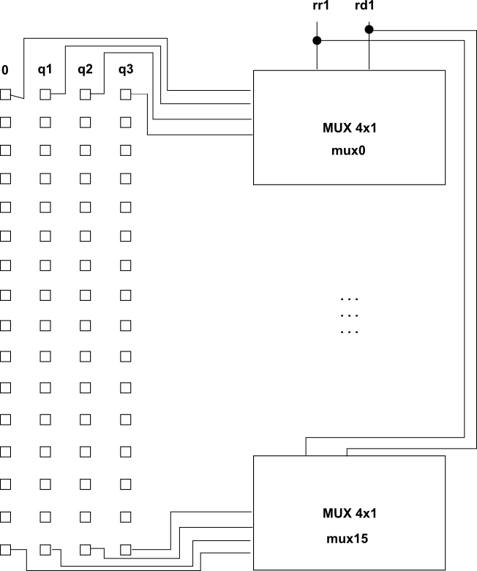

Truth Table –

4x1 Multiplexer

|  |  |  |  |  |  |
| --- | --- | --- | --- | --- | --- |
| s1 | s2 | x0 | x1 | x2 | x3 |
| 0 | 0 | 1 | 0 | 0 | 0 |
| 0 | 1 | 0 | 1 | 0 | 0 |
| 1 | 0 | 0 | 0 | 1 | 0 |
| 1 | 1 | 0 | 0 | 0 | 1 |